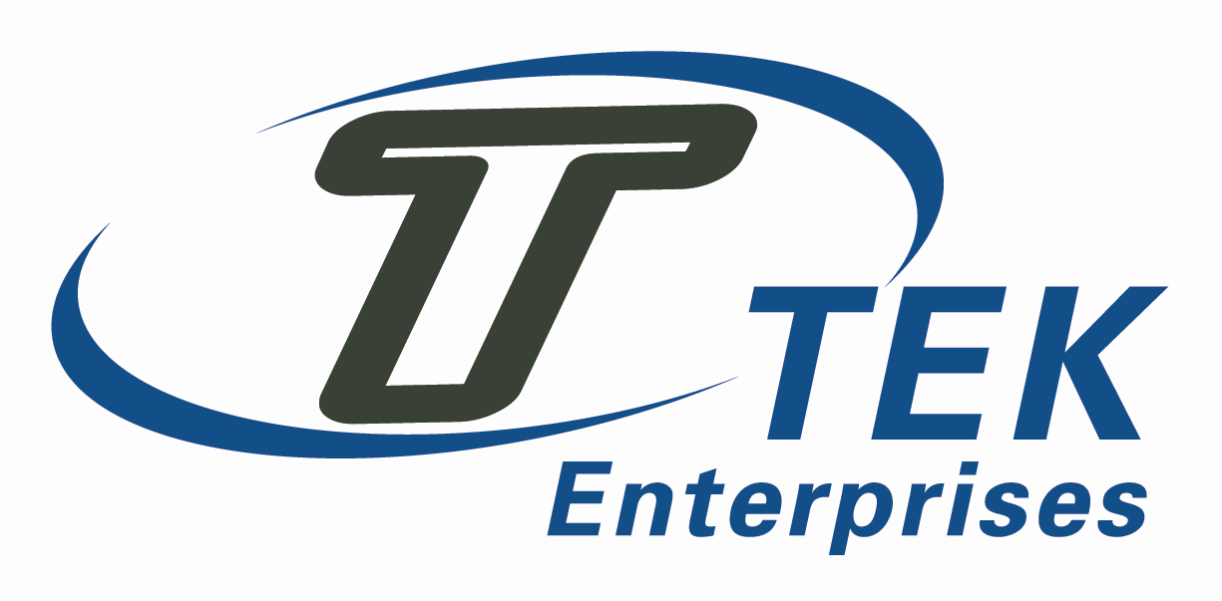
Product/Service Purchased Quality Code
Raw Material | QC01, QC02, QC04, QC05, QC06, QC07, QC15, QC17, QC20, QC21, QC22, QC23, QC24, QC25, QC26
Hardware | QC01, QC02, QC04, QC05, QC06, QC07, QC09, QC13, QC15, QC16, QC17, QC21, QC22, QC23, QC24, QC25, QC26
Heat Treated | QC01, QC02, QC03, QC05, QC06, QC07, QC10, QC11, QC13, QC15, QC17, QC21, QC22, QC24, QC25, QC26
Outside Service/Calibration | QC01, QC02, QC05, QC06, QC07, QC08, QC09, QC10, QC12, QC13, QC14, QC15, QC16, QC17, QC19, QC21, QC22, QC24, QC25, QC26

Quality Code | Title | Requirement
QC01 | Quality System | Supplier shall establish and maintain a Quality System acceptable to TEK Enterprises, for the goods and/or services purchased under this purchase order. As a minimum, the supplier's Quality System must meet the requirements of ISO9001 or better.
QC02 | AS9100 Compliant | The supplier is required to maintain a Quality System in compliance to AS9100. If facility is not certified to AS9100, buyer reserves the right to conduct surveillance at supplier's facility to make final determination that Supplier's Quality System meets the requirements, and/or supplier will be required to complete a Supplier Survey Questionnaire.
QC03 | NADCAP Approval | Special processing NADCAP approval is required. The special process requirements will be listed on the actual purchase order.
QC04 | Supplier Furnished Material | Supplier shall submit Chemical and Physical test reports in accordance with the latest material specifications and revision. Distributors must provide a certification verifying the materials traceability to the Mill test reports when supplied.
QC05 | Sub-Contractor Flow Down | Supplier is required to flow down the requirements of this purchase order, including terms and conditions to the Supplier's subcontractors. Flow down of key characteristics is required when specified on the face of purchase order.
QC06 | Record Retention and Disposition | As a minimum, the Supplier is to retain records for at least 30 years from the date of shipment under each applicable order for all products/part numbers unless otherwise specified in the order. In special circumstances, the purchase order will identify the actual required number of years that the records should be maintained. After the minimum retention period is achieved, suppliers may disposition the records as archive or destroy at their discretion.
QC07 | Measuring &  Test Equipment | The Supplier's equipment shall be calibrated in accordance with ANSI/NCLSL Z540-3 or ISO 10012-1 and traceable to NIST.
QC08 | TEK Enterprises Furnished Property | Supplier is to return all furnished property to TEK Enterprises at the completion of the purchase order. Furnished property may include but not be limited to the following: drawings, mylars, process specification, tooling, fixtures, and excess raw material.
QC09 | Parts Identification | The Supplier is to identify parts in accordance with purchase order requirements.
QC10 | Nonconformance/Corrective Action | The Supplier is to notify TEK Enterprises of any Nonconformance prior to shipping product and obtain approval for disposition of any nonconforming product. In addition, the Supplier will maintain a system of handling non-conformances and corrective actions.
QC11 | Special Processing Approval | The Supplier is to perform a special process on this purchase order. Special processing may include one of the following processes: heat-treating, stress relieving or Nondestructive testing. TEK Enterprises shall identify the specific process specification and the end user on the purchase order. The Supplier should maintain its special process approval with the end user. If the Supplier is not currently approved for the specified process, it is the Supplier's responsibility to notify TEK Enterprises immediately.
QC12 | Dimensional Inspection Report | The Supplier is to document an actual dimensional inspection report and submit it to TEK Enterprises at the completion of the purchase order.
QC13 | First Article Inspection | The Supplier to submit a First Article per AS9102 with this purchase order. It should identify all of the process specifications and dimensional data.
QC14 | Calibration Vendor | The calibration vendor shall be accredited to ISO17025. All measuring and test equipment shall be calibrated in accordance with ANSI/NCLSL Z540-1 or ISO 10012-1 and traceable to NIST.
QC15 | Packaging Protection | Supplier to package parts in a manner that will protect parts from any kind of damage. No metal to metal contact is ever allowed. In special circumstances, the purchase order may specify the manner the parts are to be packaged.
QC16 | Part Number Serialization | All parts should have unique serial numbers assigned. Supplier is to maintain tractability throughout the production stage.
QC17 | Certificate of Conformance | A certification is required, stating that all of the products or services meet the contractual or purchase order requirements. The certificate must list the part number and all of the applicable process specifications, including up to date revision levels.
QC18 | The Boeing Company Approved Process | The Supplier shall maintain a special process approval from The Boeing Company on this purchase order.
QC19 | Key Characteristics Data Required | This purchase order deals with the drawing that identifies key characteristics. Both the Supplier and TEK Enterprises should have established a control plan prior to the placement of this purchase order.
QC20 | BUY AMERICA ACT | Items procured under this purchase order must be compliant with DFAR 252.225-7000
QC21 | Right of Entry | TEK Enterprises, our customers, and/or any applicable regulatory authority reserve the right to access the supplier’s applicable areas of all facilities, at any level of the supply chain, involved in the order and to all applicable records. Reason for access may include inspection of the item on order, status of the item, or reviewing quality records pertaining to the purchase order in question.
QC22 | QMS Awareness | Vendors Personnel must be made aware of:  • their contribution to product or service conformity;  • their contribution to product safety;  • the importance of ethical behavior.
QC23 | Counterfeit Prevention | Vendor must have a process in place to detect and prevent the use of counterfeit parts/materials.
QC24 | Control & Monitoring Requirements | Vendor must maintain a Quality Level ≥98% and an OTD level ≥98%. If levels drop below target, supplier will be notified and may be placed on conditional status or disapproved if not corrected
QC25 | Change Notification | Supplier is to notify TEK Enterprises of changes in product and/or process, changes of suppliers, changes of manufacturing facility location and, where required, obtain organization approval.
QC26 | Acceptance Authority Media | Media such as inspection stamps and electronic signatures used for product acceptance/inspection must be controlled and traceable to the personnel they are issued to.

